Business Database for Supermarket Shelf

Student Names: Zequn Che, Hong Zhu

IST 659 Project Design Report



**Summary**

Nowadays, the usage of information technology is increasing rapidly in every field. A better information system helps to increase the efficiency, reduce the cost, improve the quality.

Great methods of information management make the working efficiency much higher than before. People get information earlier with higher veracity by a better information system. Information systems also help saving expenditure on manpower which is one of the most expensive parts of expenses. Repetitive actions could be avoided by the information system. Accurate controlling makes the quality of service better.

The business database of this project is for the product shelves controlling of supermarkets. The main thing to manage is the goods on the shelves. The database records every good coming to the warehouses. It helps in controlling the inventory status in the supermarkets and warehouses. The database also helps the management department to do the predictions about business. The database will help the supermarkets operating better.

The **main problem** for our project to solving is the latency time in the management of the supermarket.

1. When people shopping in supermarkets, the situations of stockout usually make customers unhappy. It is because the staff could not know the goods are out of stock in a short time. The staffs need to wait for the reports from the customers or wait until they notice the situation by themselves. The replenishment could not always be quick. The lack of goods on the shelves makes the store receiving reports of unsatisfied from the customers.

2. The latency time sometimes caused overdue foods or drugs to stay on the shelves. Once the overdue products were sold to the customers, the store will get punishments and lose fame and money.

3. The situations of the selling are hard to predict. The market could not do the perfect purchasing of the goods. The amounts and types of goods purchasing are not best optimized.

The business database could help solve the problems the supermarkets meet. The database will record every good the stores or warehouses purchased from the manufacturers. It records the names, dates of manufacture, expiration dates, prices. Every good has its ID so the managers could track every good. By using a good database, the managers will know when will some old goods need to be replaced by fresh goods.

Normal Process of the System

The products on the shelves in the supermarkets are monitoring by sensors on the shelves. The sensors could detect how many products left on the shelves. Once there is low or sold-out, the manager of the supermarket will get the notification immediately. The managers can ask employees to do replenishment from the storage of the supermarket first. If the stock is low, the managers could send orders to the warehouses for supplement early. Moreover, when a product is near its due date, the employee will get notification to move it to sales shelves or throw the overdue products away.

On the other hand, the database could record the selling so that the department of management could do prediction by the data. As a result, warehouses and inventories could be optimized a lot.

**Entities and Attributes**

|  |  |
| --- | --- |
| **Entities and Attributes** | **Description** |
| **Employee** | All the employees |
| Employee_ID | The Employee ID, Primary Key |
| Supermarket_ID | Foreign Key |
| Emp_SSN | Social Security Number |
| Emp_FName | First Name |
| Emp_LName | Last Name |
| Emp_Position | Manager/Employee/Intern |
| Emp_Address1 |  |
| Emp_Address2 |  |
| Emp_Phone |  |
| Emp_Email |  |
| Emp_Start_Date | Not null |
| Emp_End_Date | Could be null |
|  |  |
| **Supermarket** |  |
| Supermarket_ID | Primary Key |
| Manager_ID | Foreign Key |
| S_City | The city of the supermarket |
| S_State | The state of the supermarket |
| S_Address1 |  |
| S_Address2 |  |
|  |  |
| **Supermarket_Storage** |  |
| Storage_ID | Primary Key |
| Supermarket_ID | Foreign Key |
|  |  |
| **Product_in_Stock** |  |
| Storage_ID | Foreign Key |
| Product_Type_ID | Primary Key, Foreign Key |
| Product_Name | Primary Key, Foreign Key |
| Amount_in_Stock |  |
|  |  |
|  |  |
| **Manager** | Managers of supermarkets |
| Manager_ID | Primary Key |
| Employee_ID | Primary Key, Foreign Key |
| Supermarket_ID | Foreign Key |
| M_Description | Description about the manager. |
|  |  |
| **Product_Type** | The Sample of a type of products for providing the standard. |
| Product_Type_ID | Primary Key |
| Product_Name | Primary Key |
| Product_Type_Price | The standard price |
|  |  |
| **Product** |  |
| Product_ID | Primary Key |
| Product_Type_ID | Primary Key, Foreign Key, the standard of the product |
| Product_Type_Price | The standard price |
| Supermarket_ID | Foreign Key |
| Product_Name | Primary Key, Foreign Key |
| Date_of_Manufacture |  |
| Expiration_Date |  |
| Product_Price | The actual price of the product |
|  |  |
| **Warehouse** |  |
| Warehouse_ID | Primary Key |
| WH_Phone |  |
| WH_Email |  |
| WH_City |  |
| WH_State |  |
| WH_Address |  |
|  |  |
| **Replenish_Order** |  |
| Rep_Order_ID | Primary Key |
| Manager_ID | Foreign Key |
| Warehouse_ID | Foreign Key |
| Details | Description about the order |

**Entity Relational Data Model**

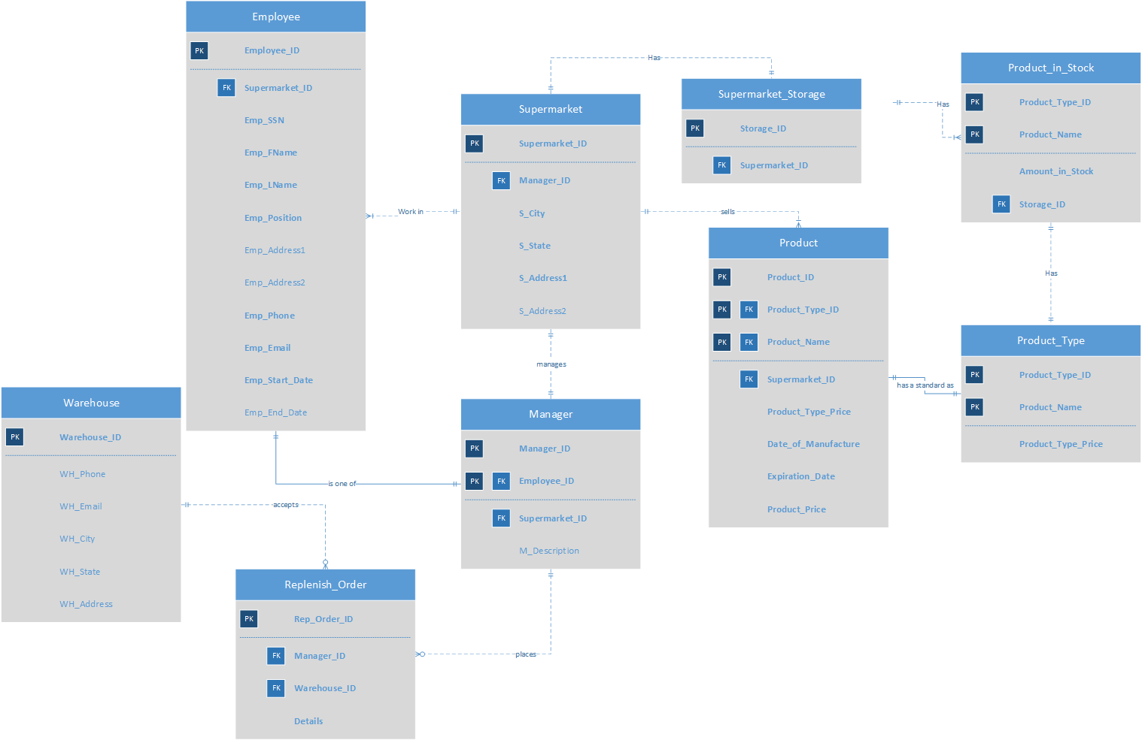

**Business Rules**

1. Every Employee should work in one and only one Supermarket.
2. Every Employee must have an SSN (Social Security Number).
3. The prices of products could be changed based on the original prices (Product_Type_Price in the database)
4. A manager can manage one and only one supermarket.
5. A supermarket can have one and only one manager.

**Major Data Questions**

1. What is the difference between product and product_type？
2. What is the basic employee configuration of a supermarket?
3. How does the management department know the remaining quantity of products?